**CS 230 Module One Assignment**

# UML Class Diagram

The following diagram represents the UML class structure. It shows the class hierarchy and object-oriented relationships among Vehicle, TwoWheeled, Bicycle, and Driver classes.

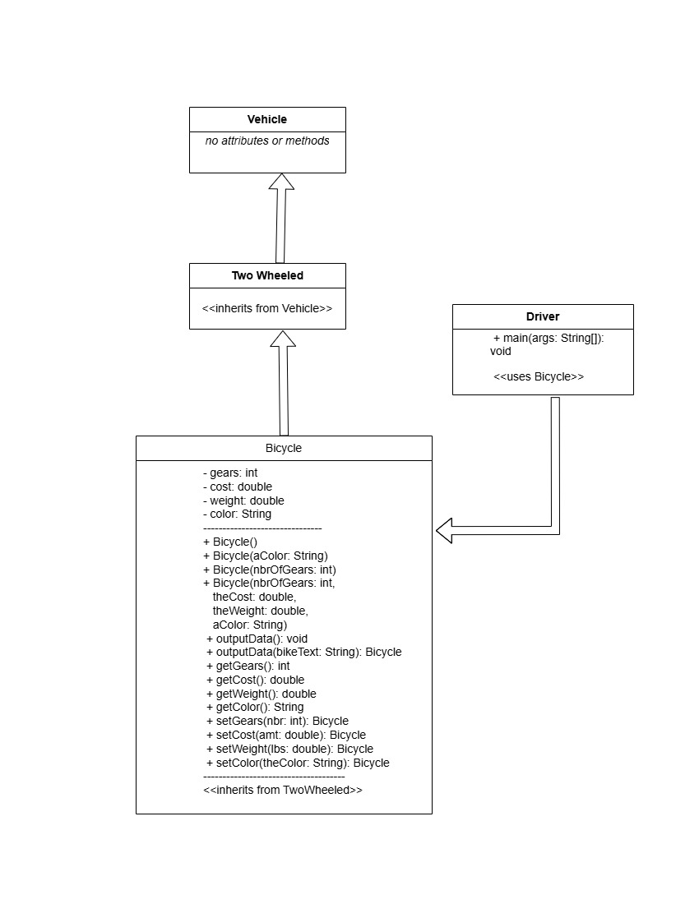

# Object-Oriented Programming Principles

This Java application demonstrates several core object-oriented programming principles:  
  
1. Inheritance:  
 - TwoWheeled extends Vehicle, and Bicycle extends TwoWheeled. This establishes a clear is-a hierarchy.  
  
2. Encapsulation:  
 - The Bicycle class uses private fields with public getter and setter methods. Setter methods return 'this' to support method chaining.  
  
3. Method Overloading:  
 - The Bicycle class includes overloaded constructors and the outputData method.  
  
4. Polymorphism:  
 - The Driver class uses instance of checks to confirm the hierarchical relationship and inheritance-based polymorphism.